Week | News Story | Focus Question | UN Article | British Value Link
24th  October | After being shut for nearly two years, the world’s most  southerly mail room on the remote Goudier Island in the  Antarctic Peninsula, will reopen under a team of British women. | Have our lives become too complicated? | 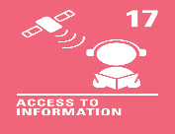 | Mutual Respect and Tolerance - I know that life is not the same for everyone. Some people’s lives may be more complicated than others. Even if we’re feeling busy or pressured, it is important to still treat others with respect.
31st  October | A robot named Ai-Da has become the first robot to speak  in the House of Lords in Westminster, London. | Will robots make the world a better place? | 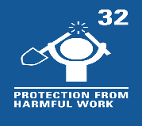 | Individual Liberty - People are responsible for advances in science and technology. It is important that risks are managed and the consequences considered carefully so that these advances help us.
7th  November | Animal rescue groups in countries around the world are seeing a jump in the number of animals being brought to their shelters, as household finances are squeezed. | Should more be done to help rescue pets? | 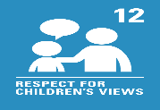 | Democracy - We all have a voice. We can use our voice to share our opinions and support the things that matter to us. For some, this might be caring for pets in need.
14th November | Pupils in schools should not be unfairly singled out for having afro hair, the Equality and Human Rights Commission (EHRC) has said in new guidelines for schools. | Should we ever have to change our appearance? | 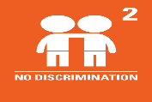 | Rule of Law - There may be rules we follow in school about how we wear our hair. Rules are often in place to protect us and keep us safe but we must ensure they are fair and do not discriminate.
21st November | The men’s FIFA World Cup 2022 has started in Qatar and will run until 18th December. | What can football teach us about the wider world? | 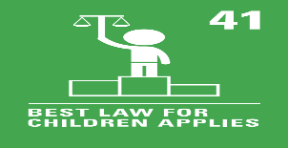 | Mutual Respect and Tolerance - World sports events provide an opportunity to learn about other countries and their cultures. Life is not the same for everyone and  we can respect our differences.
28th  November | Nurses in the Royal College of Nursing (RCN) union have voted for the union’s first UK-wide strike in its 106-year history. | Are some jobs more important than others? | 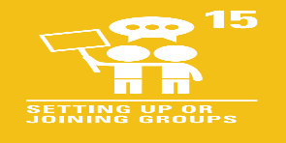 | Democracy - We all have a voice and the right to use it. Nurses in the Royal College of Nursing union have voted to strike, which is one way people can share their voice.
5th  December | This year, the BBC (British Broadcasting Corporation) marks 100 years of broadcasting. | Are television channels as important as they once were? | 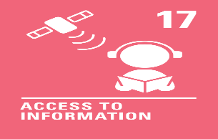 | Individual Liberty - With such a huge variety of entertainment available on our screens, we can choose what to watch. We can take some responsibility for our viewing to ensure we have a healthy amount of screen time.
12th December | Nasa officials have recently announced that humans could live on the Moon during this decade. | What would it be like to live on the Moon? | 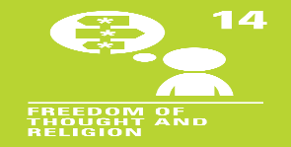 | Mutual Respect and Tolerance - We are all different so our thoughts, feelings and opinions about visiting the Moon will be different too. We can show respect for and understanding of our differences.

