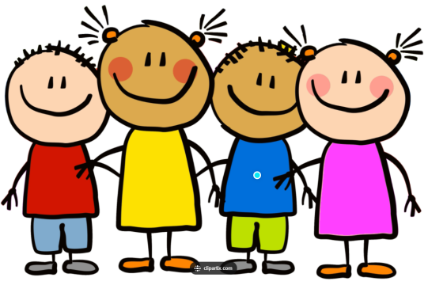
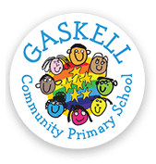
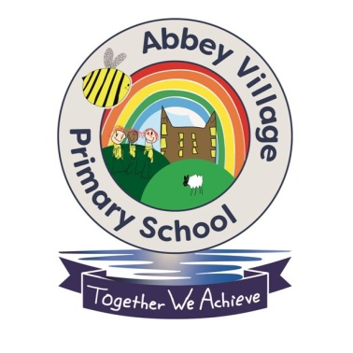

School Linking Project

To promote friendship, diversity and knowledge and understanding of the world within our school, we have teamed up with Gaskell Primary School in Bolton to make friends from different communities.

23rd June 2022
First Meeting - Friendship Walk along Withnell Nature Trail

Today we met with our new friends from Gaskell Primary School. We were very excited to see our new friends and to have lots of new people in school.

After some brief introductions in the classroom, we went on a walk together through the nature trail. In the woods, we played some 'ice-breaker' games to get to know our new friends a bit more and find out more about each other. We found that we had lots of things in common with each other. We then had a drink of hot chocolate and a biscuit in the woods whilst we chatted to our new friends, before walking back to school.
