ABBEY VILLAGE PRIMARY SCHOOL

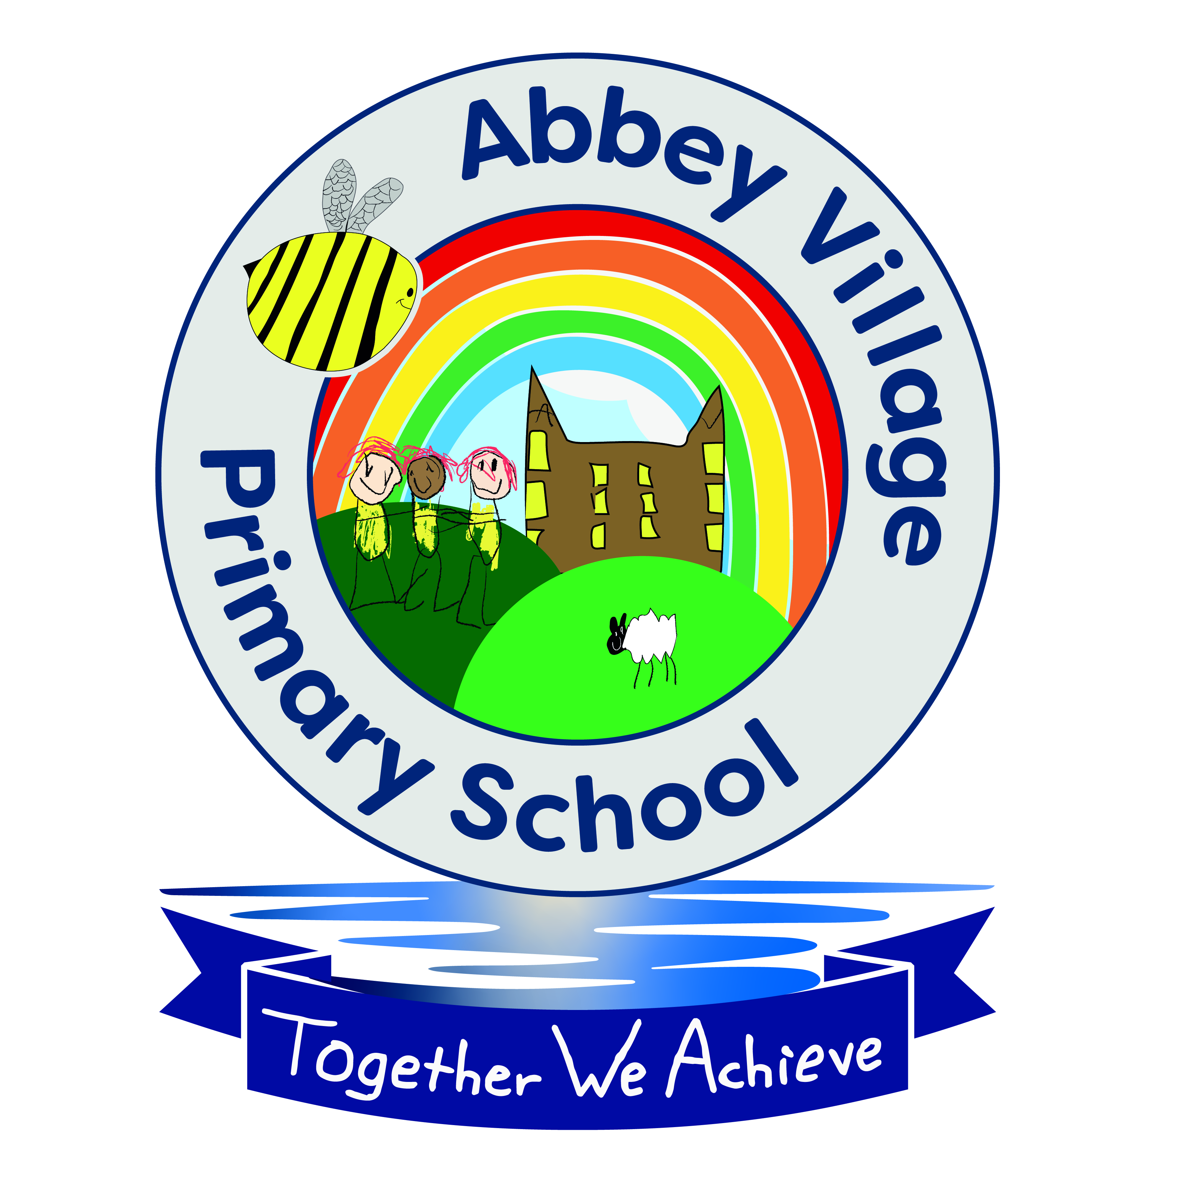

Accessibility Plan

January 2022
Agreed by Governors: March 2022
Renewal Date: January 2025

Accessibility Plan

Abbey Village Primary School is an inclusive school who actively seeks to remove barriers to learning and to ensure that we have high expectations of achievement for all. Children are provided with high quality, personalised learning opportunities so that each child attains well and achieves their potential. At Abbey Village we promote an ethos of care and trust where every member of the school family feels that they truly belong and are valued. We work hard to ensure individual talents, skills and unique characteristics are identified and celebrated, irrespective of ethnicity, faith, attainment, age, disability, gender or background. High importance is placed on learning in all its forms and all staff are committed to nurturing lifelong learners.

Abbey Village is a safe school, committed to improving children's confidence and self-esteem through our belief that safe and happy children achieve. This Accessibility Plan is drawn up in compliance with current legislation and requirements as specified in Schedule 10, relating to Disability, of the Equality Act 2010.
School Governors are accountable for ensuring the implementation, review and reporting of progress of the Accessibility Plan over a prescribed period.

The Equality Act 2010 replaced all existing equality legislation, including the Disability Discrimination Act. The effect of the law is the same as in the past, meaning that “schools cannot unlawfully discriminate against pupils because of sex, race, disability, religion or belief
and sexual orientation”. We define equality in line with the Equality Act 2010 and recognise the following protected characteristics:
- age
- disability
- gender reassignment
- marriage and civil partnership
- pregnancy and maternity
- race
- religion or belief
- sex
- sexual orientation.

According to the Equality Act 2010 a person has a disability if:

- He or she has a physical or mental impairment, and

- The impairment has a substantial and long-term adverse effect on his or her ability to carry out normal day-to-day activities.

This Accessibility Plan is structured to complement and support the school’s Equality Policy, and will similarly be published on the school website. We understand that the Local Authority will monitor the school’s activity under the Equality Act 2010 (and in particular Schedule 10 regarding Accessibility) and will advise upon the compliance with that duty.

Objectives
Abbey Village Primary School is committed to providing an environment that enables full curriculum access that values and includes all pupils, staff, parents and visitors regardless of their education, physical, sensory, social, spiritual, emotional and cultural needs. We are committed to taking positive action in the spirit of the Equality Act 2010 , with regard to disability and to developing a culture of inclusion, support and awareness within the school.

The school recognises and values parents’ knowledge of a child’s disability and its effect on their ability to carry out everyday activities. The parents’ and child’s right to confidentiality is respected.

The Abbey Village Primary School Accessibility Plan shows how access to the school is provided for disabled pupils, staff and visitors and anticipates the need to make reasonable adjustments to accommodate their needs where practicable. It is also acknowledged that a full assessment of the school’s accessibility arrangements would be necessary as and when new pupils or families with particular disabilities join the school.

The Accessibility Plan contains relevant and timely actions to:-

- Maintain and develop access to the curriculum for pupils with a physical disability and/or sensory impairments, developing the curriculum as necessary to ensure that pupils with a disability are as equally prepared for secondary school and beyond as all other pupils; (If a school fails to do this they are in breach of their duties under the Equalities Act 2010); this covers teaching and learning and the wider curriculum of the school such as participation in after-school clubs, leisure and cultural activities or schools visits –it also covers the provision of specialist or auxiliary aids and equipment, which may assist these pupils in accessing the curriculum within a reasonable timeframe;

- Improve and maintain access to the physical environment of the school, adding specialist facilities as necessary – this covers improvements to the physical environment of the school and physical aids to access education within a reasonable timeframe;

- Improve the delivery of written information to pupils, staff, parents and visitors with disabilities; examples might include hand-outs, timetables, textbooks and information about the school and school events; the information should be made available in various preferred formats within a reasonable timeframe.

The Abbey Village Primary School Accessibility Plan relates to the key aspects of physical environment, curriculum and written information. Whole school training will recognise the need to continue raising awareness for staff and governors on equality issues with reference to the Equality Act 2010.

This Accessibility Plan should be read in conjunction with the following school policies and documents:

- Special Educational Needs Policy
- Behaviour Policy
- Curriculum Policies
- Emergency Plan
- Health & Safety Policy
- School Improvement Plan
- Teaching and Learning Policy

The accessibility plan for physical accessibility relates to an access audit undertaken during annual health and safety workplace inspections, which remain the responsibility of the governing body. It may not be feasible to undertake all of the works during the life of this accessibility plan and therefore some items will carry forward into subsequent plans. An accessibility audit will be completed by the school prior to the end of each period covering this plan in order to inform the development of a new accessibility plan for the ongoing period. The terms of reference for all governors’ committees will include the need to consider Equality and Diversity issues as required by the Equality Act 2010.

The Accessibility Plan will be published on the school website.
The Accessibility Plan will be monitored through the Governor Resources Committee.
The Accessibility Plan may be monitored by Ofsted during inspection processes in relation to schedule 10 of the Equality Act 2010.

It is a requirement that the school’s Accessibility Plan is resourced, implemented, reviewed and revised as necessary and reported on annually. Attached is a set of action plans showing how the school will address the priorities identified in the plan.

The priorities for the Accessibility Plan for our school were identified by the:
- Headteacher and SENDCO
- Site Supervisor.

NB: A floor plan of the school buildings is attached as Appendix 1 in order to support this document

Action Plan A – Improving Physical Access
Item | Recommendations | Impact | Time scale | Cost | Responsibility
 |  |  |  |  | prop | school
Approach to school.  Main  entrance. | Main entrance to be kept clear. | Accessible at all times for all users. | ongoing | None |  | ✓
Approach to school  Infant entrance. | White paint to highlight step to front entrance. | All users can clearly see step. | Spring 2022 | None |  | ✓
Infant back door to playground. | White paint to highlight step to back entrance. | All users can clearly see step. | Spring 2022 | None
Corridor | Keep corridors clear from obstructions | Ease of access throughout the building for pupils or visitors with mobility  difficulties. | Ongoing | None |  | ✓
General classrooms | SENDCo to audit classroom space / provision of resources | To promote the participation and independence of all pupils. | Annually | Potential resource  / furniture implications where needs are  identified |  | ✓
WC provision for disabled users | Check existing toilet is suitable for disabled users. | Accessible facilities fit for purpose. | ongoing | none |  | ✓
WC provision | Provide resources for nappy  changing. Child step to | Nappy changing resources  available. | ongoing | Cost of changing  mat and nappy |  | ✓

for disabled users, nursery pupils  and any other required user | access changing bench. |  |  | sacs. Child step.

Action Plan B – Improving Curriculum Access
item | recommendations | impact | Time scale | Cost | responsibility

 |  |  |  |  | prop | school
intervention s  Provision  Mapping (ITP) | HT to audit current interventions and their success/impact on progress | Equal curriculum access for all pupils | Ongoing | Resourcing costs of identified areas to develop |  | ✓
Staff training in supporting pupils  with SEND – focus on key areas of need within the school: ASD | SENCO to identify training needs. Access CPD as and when necessary | Staff confident and competent to provide a curriculum which meets the needs of all learners. | Annually | Course costs – as relevant |  | ✓
Classrooms | SLT to carry out an audit of resources to ensure that the physical environment and lessons meet the needs of all  pupils in the class. | Classrooms are organised to promote the participation and independence of all pupils. | ongoing | Resource costs as relevant |  | ✓
Breakfast, after-school club provision and extra- curricular club  provision | After-school club staff, HT, staff running clubs to ensure access is available through the provision of appropriate resources and adequate forward planning. Additional staff to be provided if ratios /  needs require it. | All pupils able to access extended services and participate in school clubs | ongoing | Cost of any resources identified as necessary to enable access |  | ✓
CPD | SLT to carry out audit of SEND knowledge, identify gaps and seek external advice if  necessary | Staff can confidently meet the needs of all learners. | Annually |  |  | ✓

 | SLT to deliver staff training in supporting pupils with SEND | Staff can confidently meet the needs of all learners. | Annually |  |  | ✓

Action Plan C – Improving the Delivery of Written Information

item | recommendations | impact | Time scale | Cost | responsibility
 |  |  |  |  | prop | school
Written materials, eg. Prospectus, newsletter  etc. | School will make itself aware of the services available for converting written information into  alternative formats | Information sharing is accessible to all. | Ongoing | N/A |  | ✓
Website | School will review the format of information on the school website in order to ensure accessibility for  all parents |  | Ongoing | N/A |  | ✓

Accessibility Plan written by: Mrs. S Bennett January 2022
Validated by Governing Board; March 2022
To be Reviewed: January 2025 or before if changes require this

