Abbey Village Primary School
Handwriting Policy

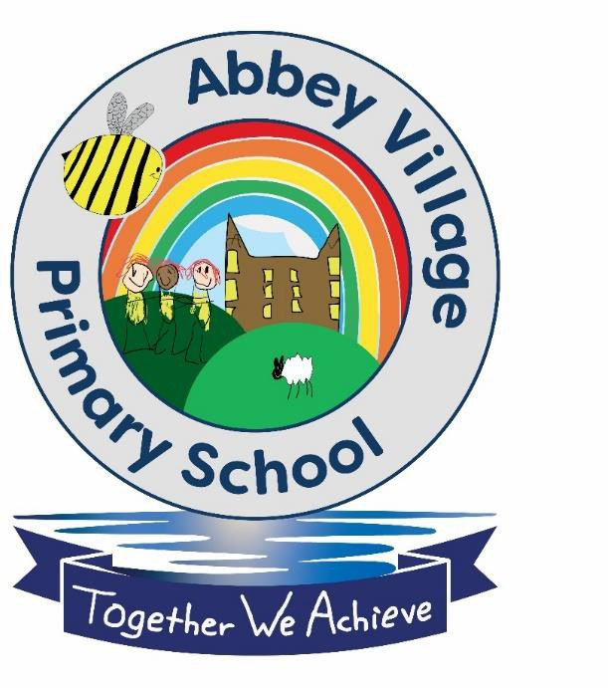

Updated January 2023
Date to be reviewed: January 2024

Abbey Village Primary School Handwriting Policy

Handwriting is a skill, which like reading and spelling, affects written communication across the curriculum. Children must be able to write with ease, speed and legibility. Cursive handwriting teaches pupils to join letters as a series of flowing movements and patterns. Handwriting skills should be taught regularly and systematically.

Aims
- To have a consistent cursive approach across the whole school to ensure high levels of presentation.
- To adopt a common approach towards handwriting by all adults when writing in children’s
books, on the whiteboard or on displays/resources.
- Children to achieve a neat, legible style with correctly formed letters in cursive handwriting.
- Children to develop fluency and speed whilst writing, so that eventually the children are able to write the letters with confidence and correct orientation.

As recommended by the British Dyslexic Association, Abbey Village adopt a cursive style of writing. Teachers and Learning Support Assistants model the agreed cursive style when modelling writing both in class, on displays and in feedback in books. Children should experience this coherence and continuity in teaching and learning across the school. Each and every member of the school should understand the importance of clear and neat presentation in order to communicate meaning clearly. All children at Abbey Village are encouraged to take pride in the presentation of their work and therefore use their skills with confidence, eliciting a sense of enjoyment and achievement.

Knowledge, Skills and Understanding Early Years
Children take part in activities to develop their fine and gross motor-skills and recognition of patterns, for example, to form letters using their index finger in sand or using paint. Children should begin to learn how to correctly hold a pencil, then how to use a pencil, holding it effectively to form recognisable letters, most of which are correctly formed. At Abbey Village, all children starting in Reception will learn to form every letter with an entry and exit stroke. This is a solid foundation for teaching joined handwriting later on. Children are taught that every letter starts on the line.
Constant repetition is the key, emphasising the correct entry and exit strokes every time.

Key Stage 1
Children will continue to develop fine and gross motor skills with a range of multi-sensory activities. Handwriting is discussed within phonics sessions. Teachers and support staff continue to guide children on how to write letters, correctly, using a comfortable and efficient pencil grip. Children should now be leaving spaces between words accurately. They are taught to be consistent with the size and shape of letters and children should be able to show that letters sit on the line and ensure that ascenders reach the appropriate height and that descenders sit below the line.

Key stage 2
During this stage, the children continue to have direct teaching and regular practice of handwriting. We aim for them to develop a clear, fluent style and by the end of Key Stage 2 can adapt their handwriting for the following different purposes: neat legible hand for finished, presented work, a faster script for note making and an appropriate style for labelling diagrams etc.

Left-handed pupils
All teachers are aware of the specific needs of left-handed pupils and make appropriate provision:
- Paper should be positioned to the left for right -handed pupils and to the right for left- handed pupils and slanted to suit the individual in either case.
- Pencils should not be held too close to the point as this can interrupt pupils’ line of vision.
- Pupils should be positioned so that they can place their paper to their left side.
- Left- handed pupils should sit to the left of a right-handed child so that they are not competing for space.
- Extra practise with left-to-right exercises may well be necessary before pupils write left-to-write automatically.
Teachers are aware of the fact that it is very difficult for left-handed pupils to follow handwriting movements when a right-handed teacher models them. Teachers demonstrate on an individual or group basis.

The learning environment
In all classes, pencil pots with suitable materials are available for pupils to work at their own tables. Classrooms are equipped with a range of writing implements, line guides, word lists and dictionaries.

Books will be regularly monitored, and extra support will be given where necessary.
In Reception and at the beginning of Year 1 the children learn to form each letter separately. Their writing will look something like this. As the children are introduced to the digraphs and trigraphs they begin to join certain letter combinations.

Aa Bb Cc Dd Ee Ff Gg Hh Ii Jj Kk Ll Mm Nn Oo Pp Qq Rr Ss Tt Uu Vv Ww Xx Yy Zz
qu ch sh th ng ai ee igh oa oo ar ur er ure

Towards the end of Year 1 and moving into Year 2, the children begin to join whole words and their writing will begin to look more like this.

The quick brown fox jumps over the lazy dog.

The English subject leader is:
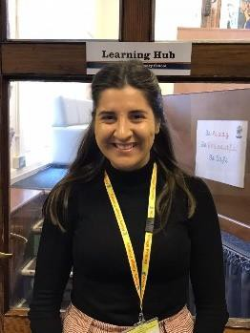

Miss Rachel Hopkins

Policy written by: Rachel Hopkins Presented to governors: July 2020 Policy to be reviewed: Annually
Reviewed January 2023

