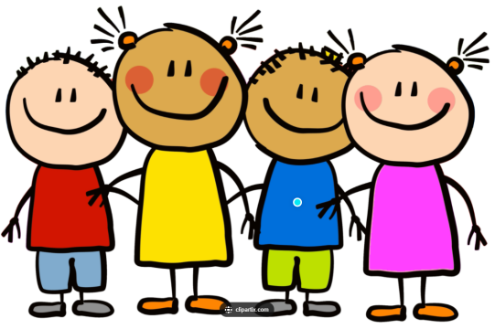
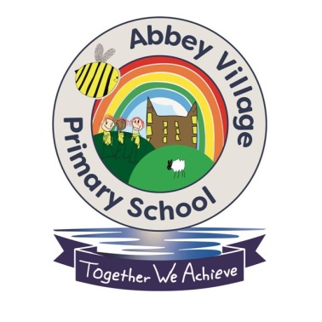

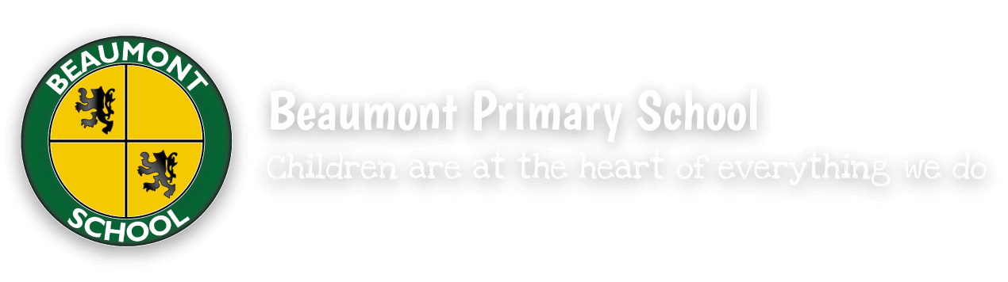

School Linking Project

To promote friendship, diversity and knowledge and understanding of the world within our school, we have teamed up with Beaumont Primary School in Bolton to make friends from different communities.

28th March 2023
Tour of Abbey Village

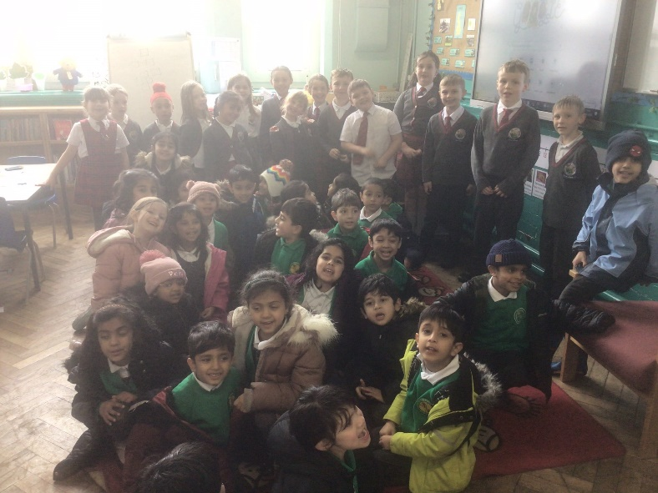
Today we met with our new friends from Beaumont Primary School. We were very excited to see our new friends and to have lots of new people in school.

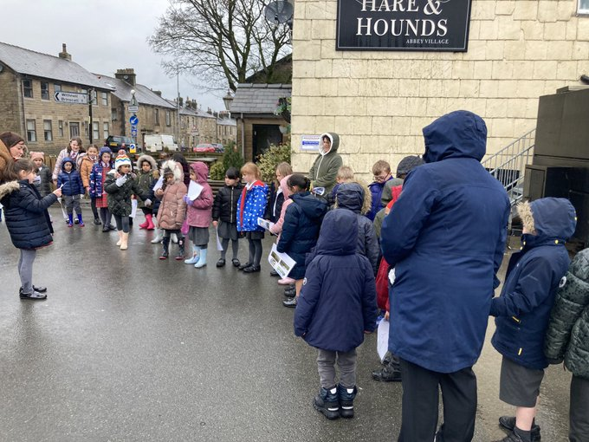
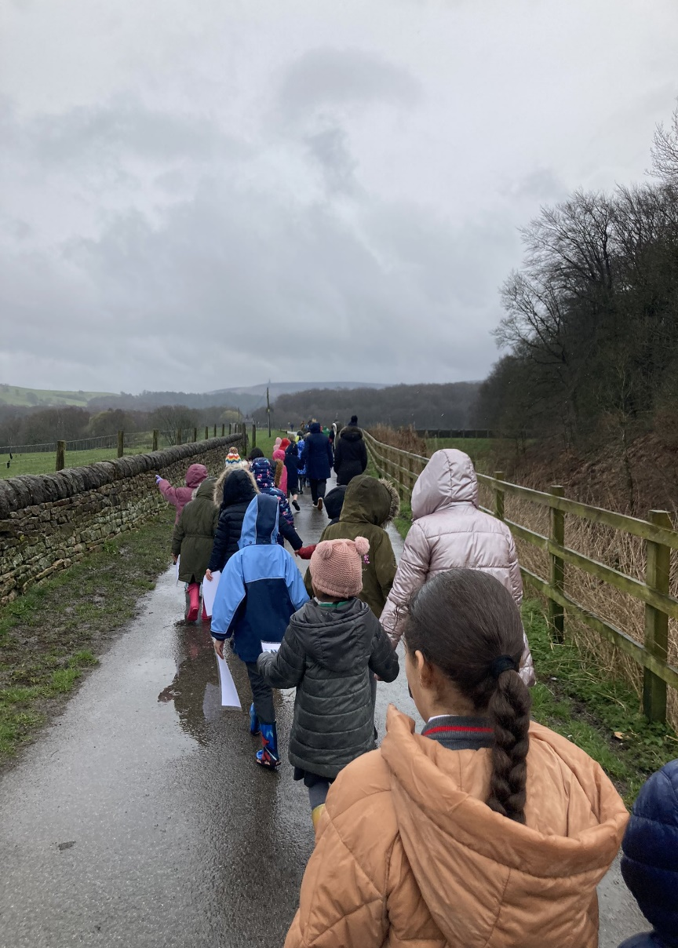
After some brief introductions in the classroom, we went on a walk together through village. Abbey Village children shared their knowledge about our village with our new friends and gave them a guided tour of the local area. Even though the weather was not kind, we had a great afternoon!

