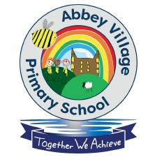

School Council Meeting Minutes – 06.09.23

Our first school council meeting for 2023/ 2024 was held on 6th September 2023. Our School Council had a very important job for the beginning of the year. We were discussing and looking at our very important child friendly policies and documents to ensure that they encompass everything that is important to our school and how and what makes Abbey Village Primary school a place like no other.
The key policies and documents that we were looking at were the following:
- What is online safety about?
- Abbey Village Primary School Safeguarding policy for our children
- What is bullying?
- Abbey Village Primary School- Child on Child abuse policy- Keeping Abbey Village Primary School Safe and Happy.
As a school council, we read and discussed each of the policies at length and our school council were fantastic at adding in some key points that they thought were important to provide our children with extra information and detail. Our school council emphasised and showed great knowledge of how to keep safe and the importance of speaking out if anything is ever wrong. It was clear that they know they can come to any member of staff in our school to speak to them and they would know they would be supported and helped.
Our school Council also wanted to add on that they believed ‘Abbey Village is our safe place’.
Our first job was a massive success and we look forward to continue to work on our fantastic School Council Role.

