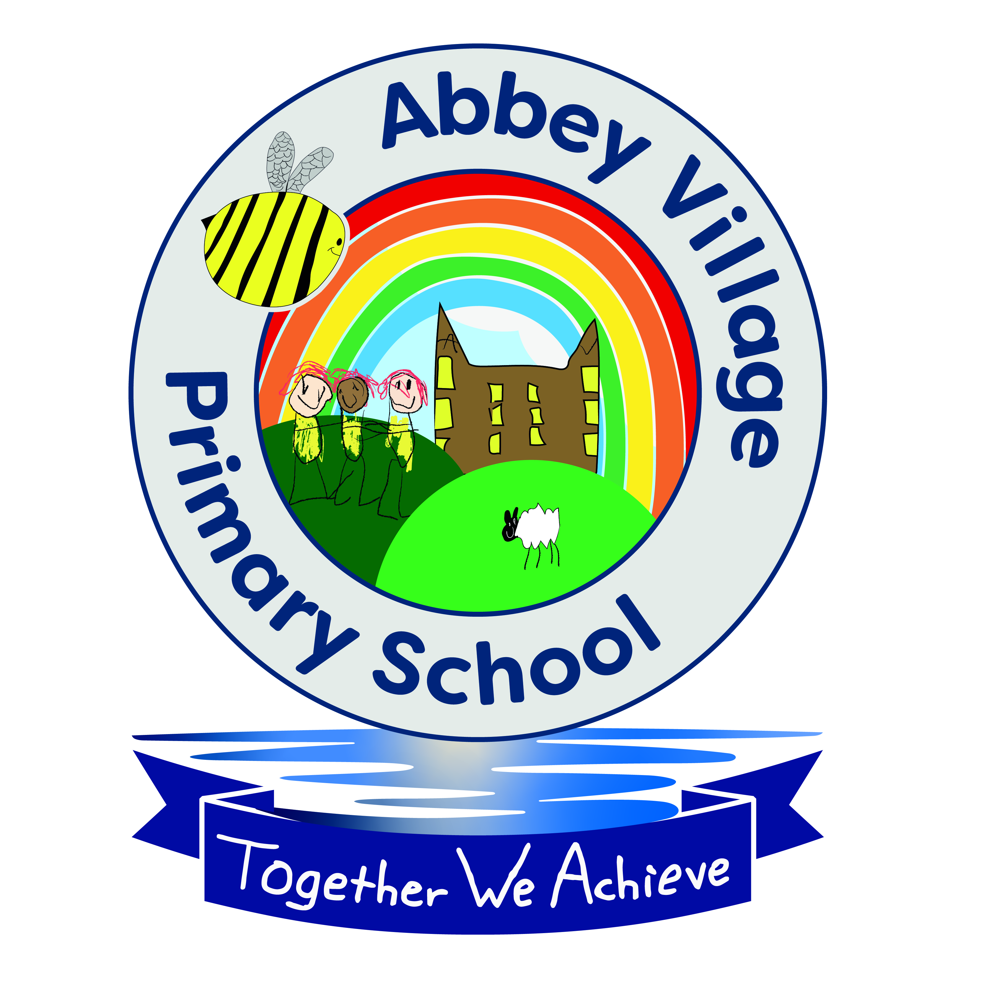

Wrap Around Care Activities

At Abbey Village Primary School, our Wrap Around Care is provided by well qualified school staff who are well known to the children. Activities vary daily. It is the child's choice what they would like to do and we tailor our activities to the needs and desires of our children to ensure it is a pleasure for them to come to both our Breakfast and After School Care.

Suggested activities include:

- Outdoor play- free or adult led in playground or nature garden
- Indoor dancing or gymnastics
- Creative Activities- free or adult led e.g. sewing, making, Playdough, colouring etc
- Construction - Lego
- Small World Play
- Homework support if required or requested by the child
- Quiet/ chill out area if requested by the child
- Friday Film Club Popcorn

