Progression in Number Facts
Year 1-5
2020

Rationale:
The National Curriculum makes references in each year group’s objectives to children developing knowledge of number facts in order for children to become fluent mathematicians. Facts must be taught and revised by children so they know relevant sets of facts by the end of each term. Where possible, different representations of each fact must be taught to secure deeper knowledge of them by children for example, when learning number bonds to 10, children must not just learn additive facts but related subtraction and missing number facts.

Teaching:
In order for the children to learn the number facts given, directed teaching time must be given. Facts can be taught in any way, either through dedicated teaching, or, more valuably, as part of the main maths lesson so as children practice and then apply the facts they have learned to their maths work.

Assessment:
The number facts presented each term should be assessed regularly in order to ensure that children know and can use them by the end of the term. For Key Stage 1 this might mean that children are assessed as with EYFS, where observations are made about the way in which children use facts when problem solving. For Key Stage 2, more summative testing might be used to assess which facts children are more or less secure with.

Application:
As well as number facts being taught as ‘stand-alone’ facts, they should also be taught in context. The aim is that when learning 3 x 5 for example, children understand this as an array, as 3 lots of 5p, as 3 boxes of 5 sweets, as 15 shared between 3 x 5 could also relate to the area of a rectangle. Where possible, children must be given opportunities to use the number facts they are learning as part of their maths lessons, knowing for example that 13 x 7 can be done mentally (10 x 7 and 3 x 7 ) rather than using a written method.

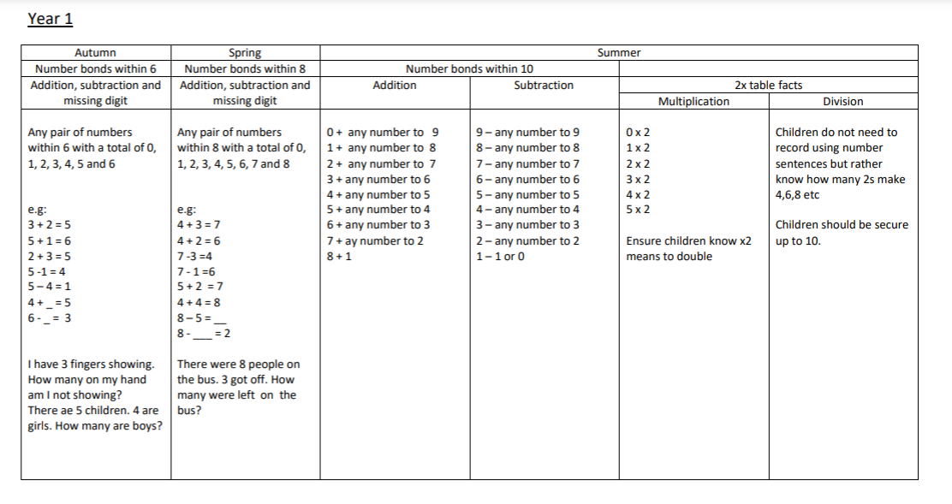

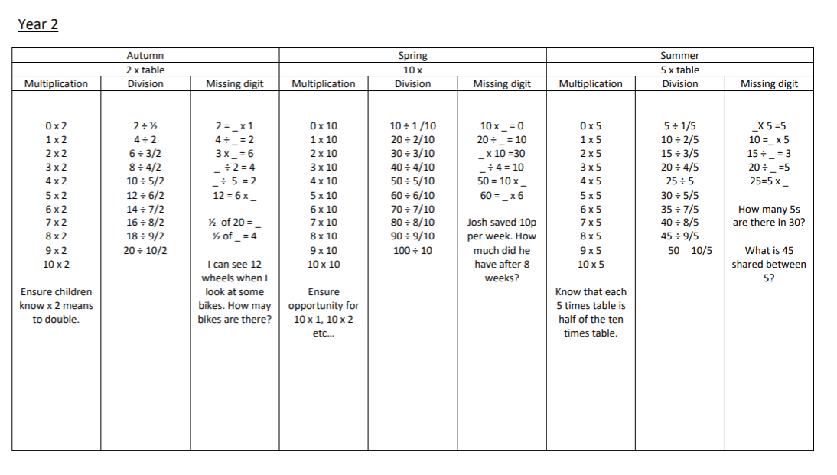

Year 3
Autumn |  |  | Spring |  |  | Summer
4 and 8 times table |  |  | 3 and 6 times table |  |  | 9 times table & revision
Multiplication | Division | Missing digits | Multiplication | Division | Missing digits | Multiplication | Division | Missing digits
O x 4/8  1 x 4/8  2 x 4/8  3 x 4/8  4 x 4/8  5 x 4/8  6 x 4/ 8  7 x 4/8  8 x 4/8  9 x 4/8  10 x 4/8  11 x 4/8  12 x 4/8 | 4 ÷ 1 / 4  8 ÷ 2 / 4  12 ÷ 3 / 4  16 ÷ 4 / 4  20 ÷ 5 / 4  Up to  40 ÷ 10 / 4  8 ÷ 1 / 8  16 ÷ 2 / 8  24 ÷ 3 /8  32 ÷ 4 /8  40 ÷ 5/ 8  Up to  80 ÷ 10 / 8 | 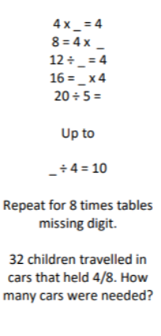 | 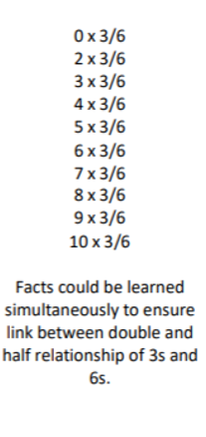 | 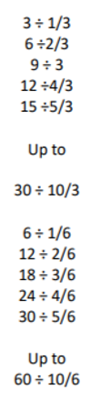 | 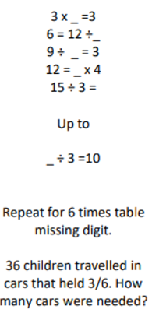 | 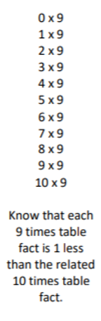 | 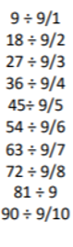 | 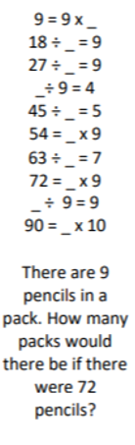

Year 4
Autumn Sppring Summer
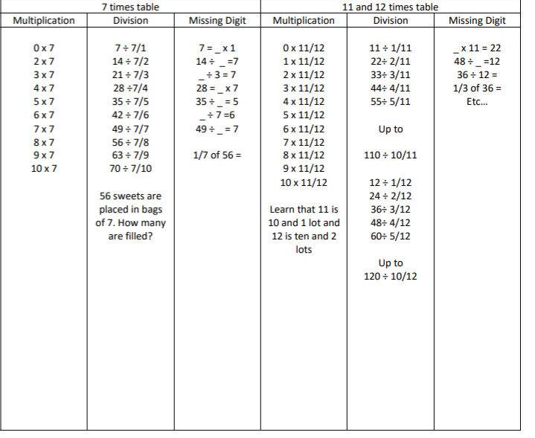

Consolidate multiplication and division facts for
tables to 12 x 12
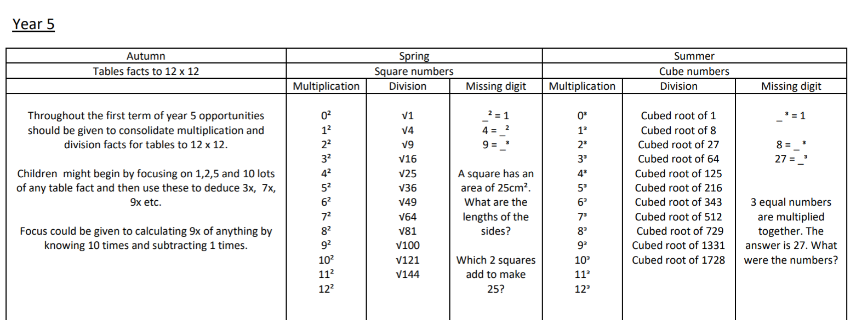

Ongoing focus on developing mental addition and subtraction as well as using and applying known facts 3 x 4 = 12 to make 30 x 40 = 1200

